KristiSaliasi — Collaboration Diagrams (Corrected)
CC_LMS_37 through CC_LMS_41 | Corrections per Professor Feedback

CC_LMS_37 — Submit Ratings and Reviews
CC_LMS_37 - Submit Ratings and Reviews

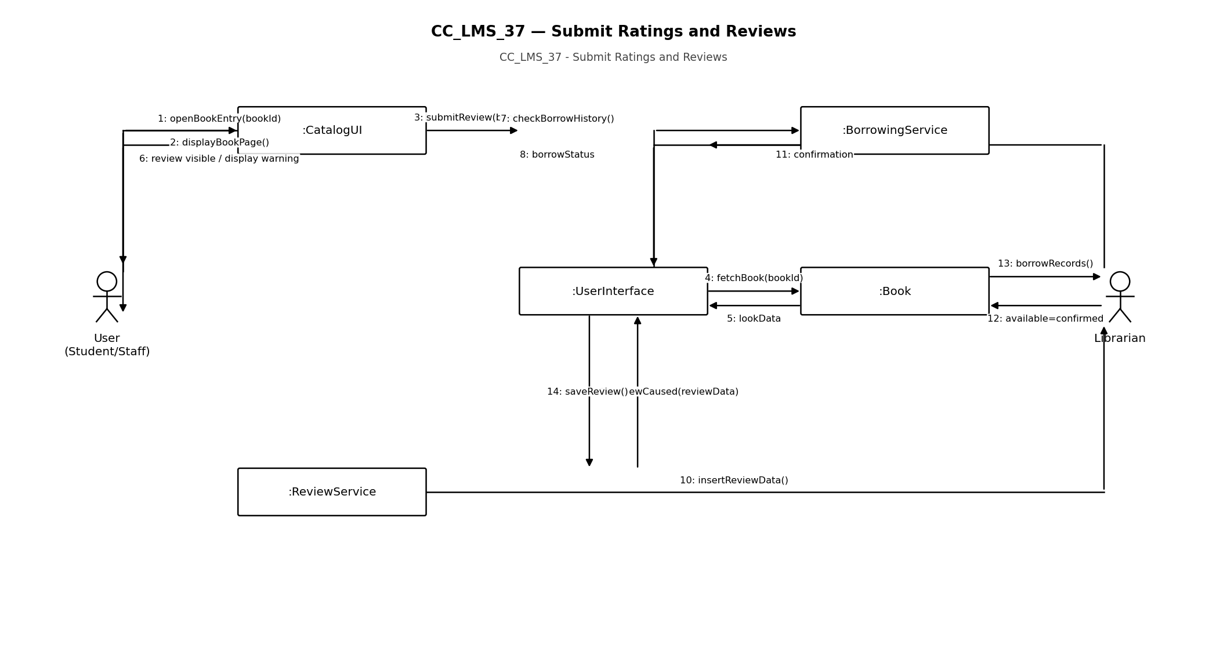

CC_LMS_38 — Provide System Feedback
CC_LMS_38 - Provide System Feedback

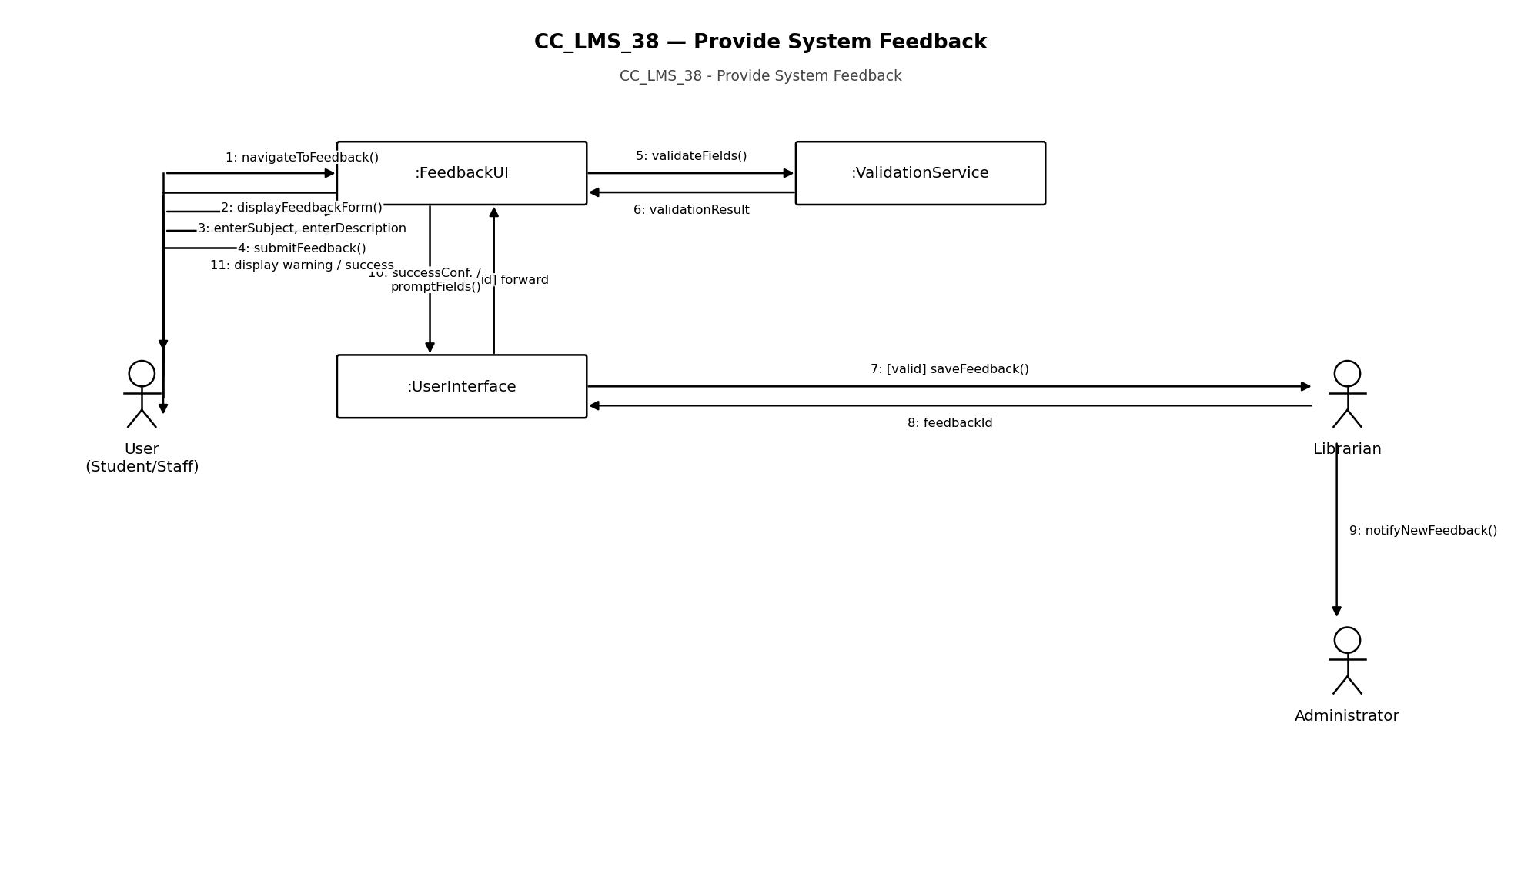

CC_LMS_39 — View Personalized Recommendations
CC_LMS_39 - View Personalized Recommendations

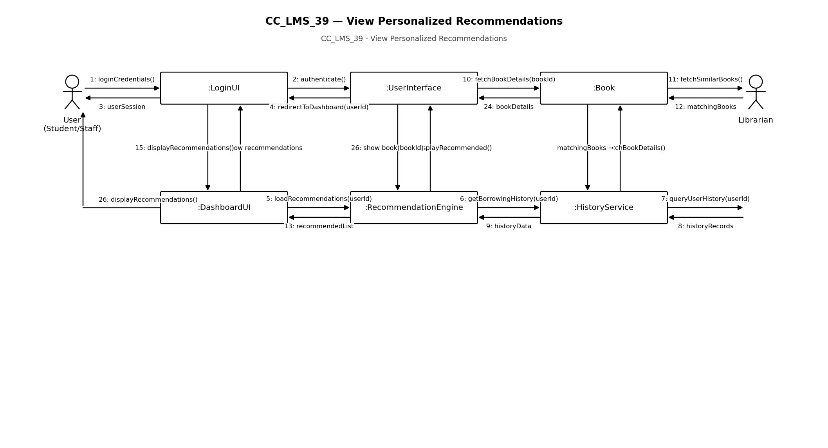

CC_LMS_40 — Manage Personal Wishlist
CC_LMS_40 - Manage Personal Wishlist

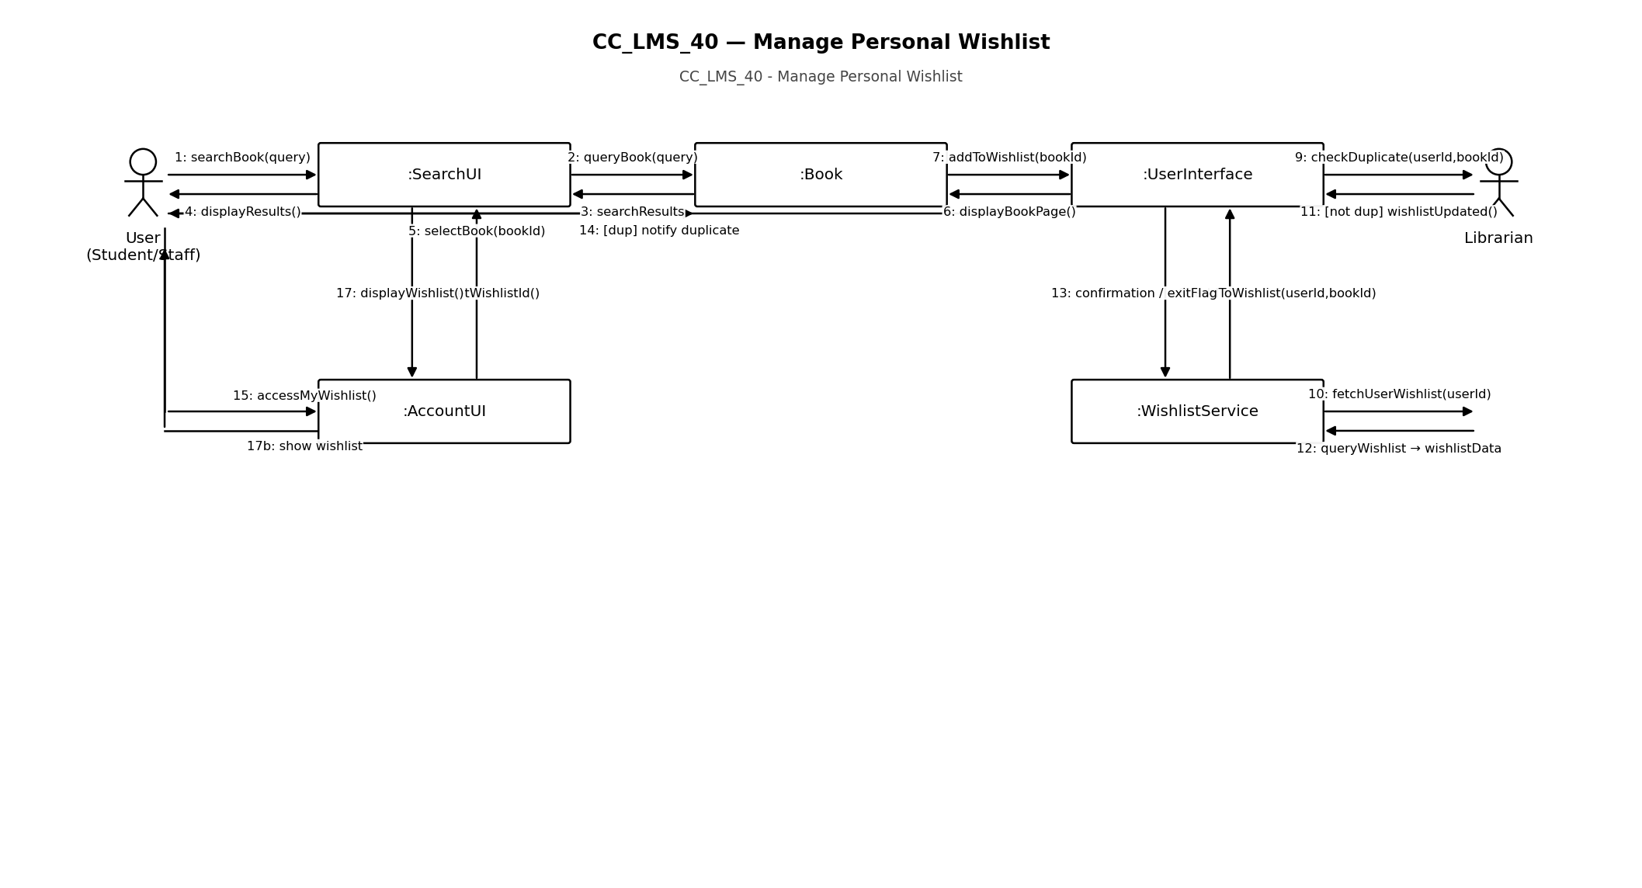

CC_LMS_41 — Respond to User Reviews
CC_LMS_41 - Respond to User Reviews

